**Canadian Institute of Technology**

Faculty of Engineering

Software Engineering Department

**Online food ordering system and management**

*A project submitted*

*in partial fulfilment of the requirements for the degree of*

*Bachelor Studies in Software Engineering*

**by**

Ana Laze

**Supervised by**

Prof.Dr. Özcan Asilkan

MSc. Ibrahim Cekirri

**UNDERTAKING**

This is to declare that the project entitled “Online food ordering system and management” is an original work done by me, in partial fulfilment of the requirements for the degree “Bachelor of Software Engineering”.

All the analysis, design and system development have been accomplished by me. Moreover, this project has not been submitted to any other college or

university.

Ana Laze



**ABSTRACT**

This application will provide customers with a great opportunity to order their foods online, without struggling to go physically to the restaurant and will help the business to manage its online orders and quantities available, since it will *keep track of the necessary information about the customers*, *payments they have to do* and the *quantity of a particular product left after the order is done*.  The application consists of two panels: the first panel of the project serves as a quantity registration system, while the second one is the food ordering system. Both systems are linked to each other. Quantities are entered in the first system, these quantities will decrease as orders are made in the food ordering system so there will be a need for entering new quantities, creating so a chain.

**Table of Contents**

LIST OF TABLES                                                                                                                              v

LIST OF FIGURES                                                                                                                           vi

1.   Software Requirements                                                                                         1

2.   Background                                                                                                                                1

*2.1 UML Diagrams* 2

*2.2 Tables*                                                                                                                                   2

3.   Conclusion                                                                                                                                3

References

**LIST OF TABLES**

Table *2.2.1*: data coming from the application

Table *2.2.2: data inserted*

**LIST OF FIGURES**

Fig.2.1.1: Browse table **Orders** 2

Fig. *2.1.2*: Structure of table **Orders**

Fig. *2.1.3* Browse table **Items**

Fig. *2.1.4* Structure of table **Items**

This chapter comprises background of the project, the reasons for taking it, problems addressed by the project and expected outcomes. The necessary background information is provided to establish context of the project. The motivation and significance of the project are highlighted.

1. **Software Requirements**

**CPU**

500MHz CPU minimum

1.4GHz processor recommended for some features

**RAM**

256MB RAM minimum

512MB recommended for certain functions in Outlook  
1GB required to use Instant Search in Outlook or the contextual spell checker in Word

**Hard drive space**

2GB free hard drive space for installation; final amount used depends on which features are installed

**Media drive**

CD or DVD drive

**Monitor**

Monitor capable of 1024x768 resolution

**Operating system**

Windows XP with Service Pack 2 or later

Some features require Windows XP Tablet PC Edition.

Certain features, such as OneNote 2007’s print driver, Groove server folder synchronization, or Office Clean-up wizard, are not available on 64-bit versions of Windows.

**Browser**

Internet Explorer 6.0 or later, 32-bit browser only

**Other hardware**

Microphone and audio output device required for speech recognition functions

**2. Background**

The title of the project is “Online food ordering system and management”. It consists of two panels. The first panel of the project serves as a *quantity registration system*. The manager of the business enters quantities for each product to be available for the clients that will be registered to the table “items”. Then, in the second panel the customer chooses the product(s) he wants to order (food, drink, dessert) with their respective quantities. He is obliged to order at least one product! Then the program calculates the costs of all the products, subtotal and total based also on the fixed tax rate. It prints the receipt and asks the user to fill out all the necessary information like name, address which will be then added to the table of the database called “orders”. After the order is done, the quantities that the user has chosen are subtracted from the quantities available that the manager has registered into the system and when the quantity is less than 10, the system warns the manager that the quantity of a certain product is at limit. Then the manager updates the quantities again and the process goes on.

***2.1 UML Diagrams***

In the Wamp server I have created the database. There I have created two tables

*Browse:*

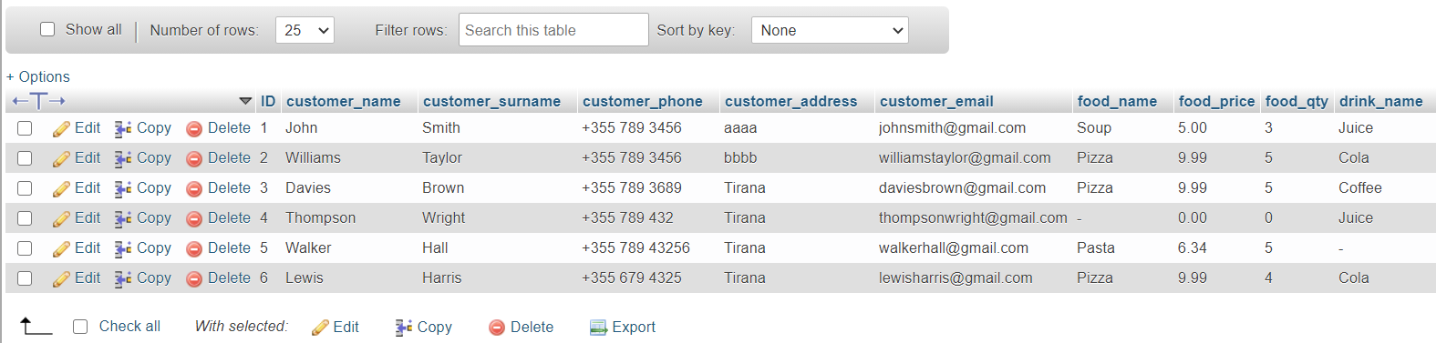

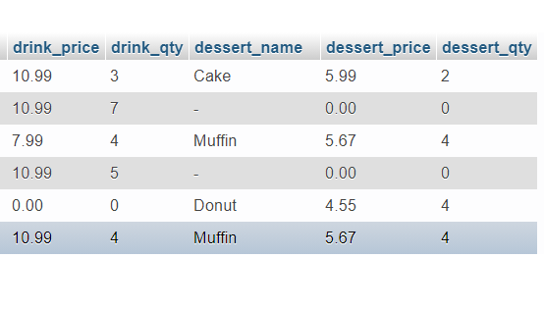

Fig.2.1.1: Browse table **Orders**

*Structure:*

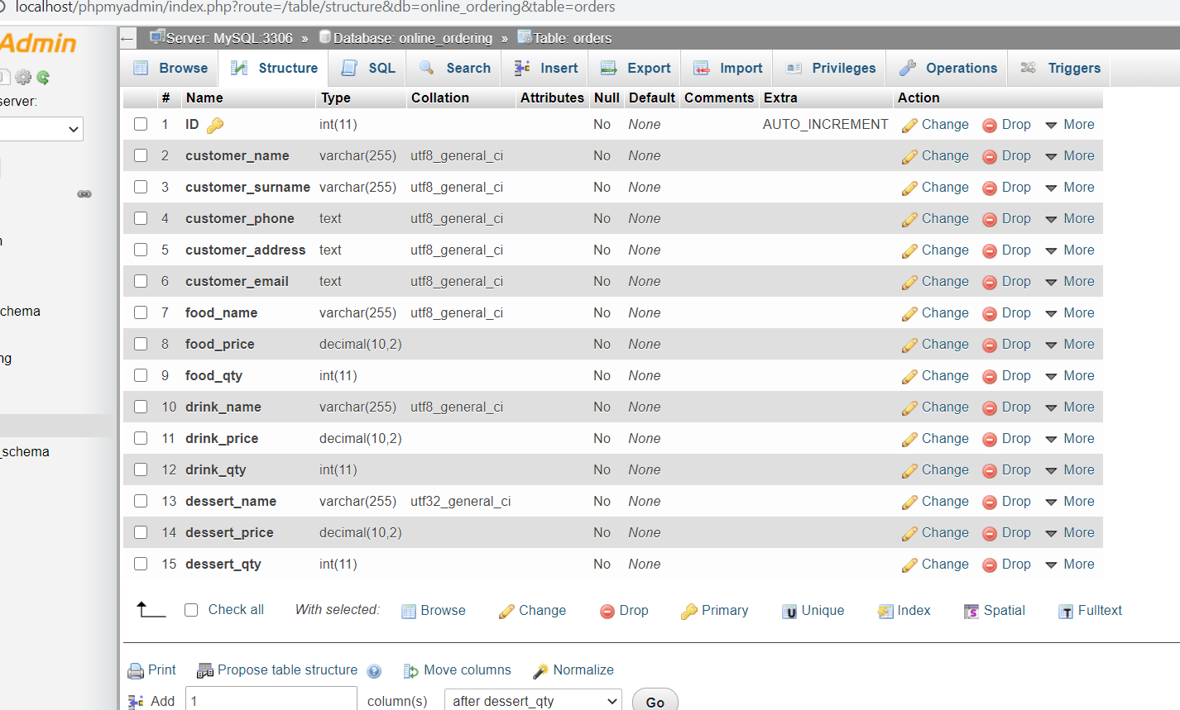

Fig. *2.1.2*: Structure of table **Orders** Table: **Orders**

*Browse:*

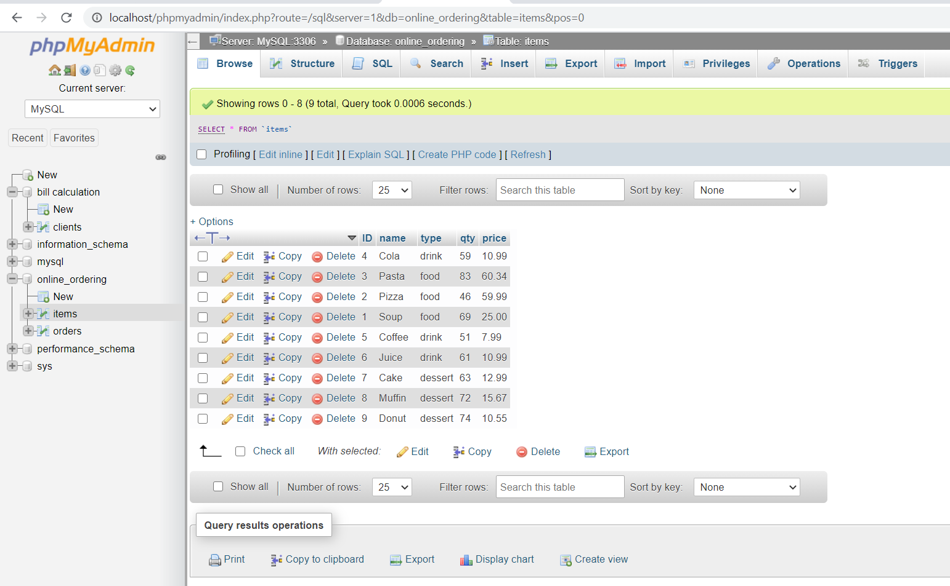

Fig. *2.1.3* Browse table **Items**

*Structure:*

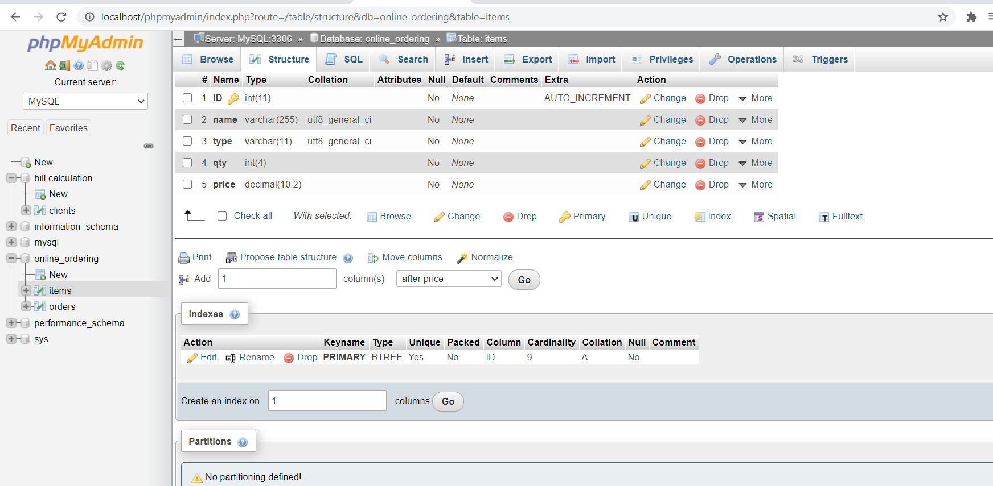

Fig. *2.1.4* Structure of table **Items** Table: **Items**

***2.2 Tables***

Table *2.2.1*: data coming from the application

**Orders**

|  |  |  |  |  |  |  |  |  |  |  |  |
| --- | --- | --- | --- | --- | --- | --- | --- | --- | --- | --- | --- |
| **ID** | customer name | customer  surname | customer phone | customer  address | customer  email | food  name | food  price | food  qty | drink  name | drink  price | drink  qty |

|  |  |  |
| --- | --- | --- |
| dessert  name | dessert  price | dessert  qty |

Table *2.2.2: data inserted*:  
  
**Items**

|  |  |  |  |  |
| --- | --- | --- | --- | --- |
| **ID** | name | type | qty | price |

**3. Conclusion**

Benefits and attributes of the project are that it firstly serves as quantity registration system, which means that the manager can chose a product and can enter quantities of all the products being available. These quantities will be available for the customers who want to make orders in the online ordering system. This system will provide the business with customers information and total costs they have to pay and also will generate a receipt with all this information. All the quantities they have ordered will be subtracted from the quantities registered from the manager, who will be asked to add new quantities when they meet a certain number. Put in another way, this system has many practical attributes that can be applied by businesses but can also be improved by offering to them the opportunity to change the items and to provide their personal menu which in this case is fixed.

**References**

# Oamen DJ. (2016, March 28). How to Create Restaurant Management System with Java Program in Eclipse - Full Tutorial. Retrieved March 1, 2022, from <https://www.youtube.com/watch?v=sOwtzVn0hv4>

HowToDoInJava. (2022, February 25). Formatting with Java DateTimeFormatter. Retrieved March 1, 2022, from <https://howtodoinjava.com/java/date-time/java8-datetimeformatter-example/>

ProgrammingKnowledge (2013). Java prog#140. How to make textfield that only accepts numbers [Online Video] Retrieved from <https://www.youtube.com/watch?v=9B5ZgItFxNA>

University Information Technology Services. (2022, March 1). ARCHIVED: What is Microsoft Office 2007, and what are the system requirements? Retrieved March 1, 2022, from <https://kb.iu.edu/d/aupn>